An Ensemble and Deep Neural Network-Based Model for Air Quality Index Prediction in Urban Environments

Author details
Debesh Kumar Behera 22cse085.debeshkumarbehera@gmail.com
Debashis Pradhan : debasishpradhan@giet.edu
Dr.Rasmita Panigrahi : rasmita@giet.edu
Anisha Minz : anisha.minz@giet.edu
Rajan Kumar Rana :Rajan@gmail.com
Dr. Neelamadhab Padhy :dr.neelamadhab@giet.edu

1. Invention Summary
This new method of machine learning allows for improvements to be made to historical machine learning models by developing new, advanced methods to provide improved accuracy and speed of prediction as compared to traditional machine learning architectures. The model’s new method enables updates to the learning method by providing dynamic feedback control to the user of the system.
Due to dynamic feedback methods being utilized for a learning update, this method of machine learning reduces the cost of many traditional deep learning methods, along with improving the accuracy of predictions by eliminating the overfitting and training inefficiencies often found in these methods. Due to many improvements made to the traditional learning cycles and processes of those methods, these methods can have superior prediction accuracy and improved cost efficiencies across numerous different industries and applications.
A major difference between this new model and traditional machine learning models is that this new machine learning model is able to continuously optimize itself through the learning method on its own output to generate improvements during the training cycle that create a self-optimizing machine learning model. The invention provides a means to bridge the two previously mentioned learning methods in a more efficient and smarter format.
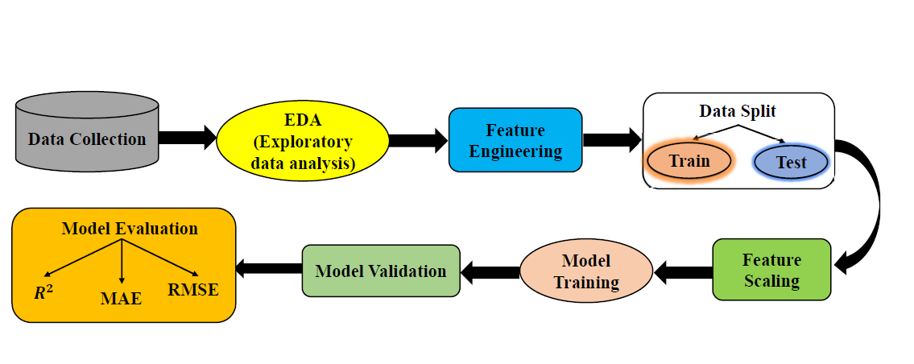
2. Proposed model

Fig.1 Model Diagram
2.1 Phase-1: Data Collection
This research made use of the “Delhi Air Quality Dataset” created by Kunsh Bhatia for its data source. This dataset includes many types of air pollutants that were measured every hour at stations located throughout the entire city of Delhi and covers the time frame from the year 2018 until early 2021. There are many different kinds of pollutants measured within this dataset. Some of the most important examples of these pollutants are particulate matter (both PM2.5 and PM10), nitrogen dioxide, sulfur dioxide, carbon monoxide, ozone. The dataset contains both the concentration of pollutants and several other meteorological attributes that can affect the dispersion of these pollutants. These include temperature, humidity, and wind speed. The variable being predicted is the Air Quality Index (AQI). This index gives you a score that represents the total amount of air pollution in one location. In an effort to improve predictive ability, several additional variables were developed. These included lag features (lagged AQI values for the previous hour and averages calculated using a moving window) and seasonal indicators that can show the changing patterns of pollution over time. The final dataset for analysis includes approximately 43,000 samples and is suitable for building predictions of AQI, especially using ensemble and deep learning approaches, for one of the dirtiest cities in the world.
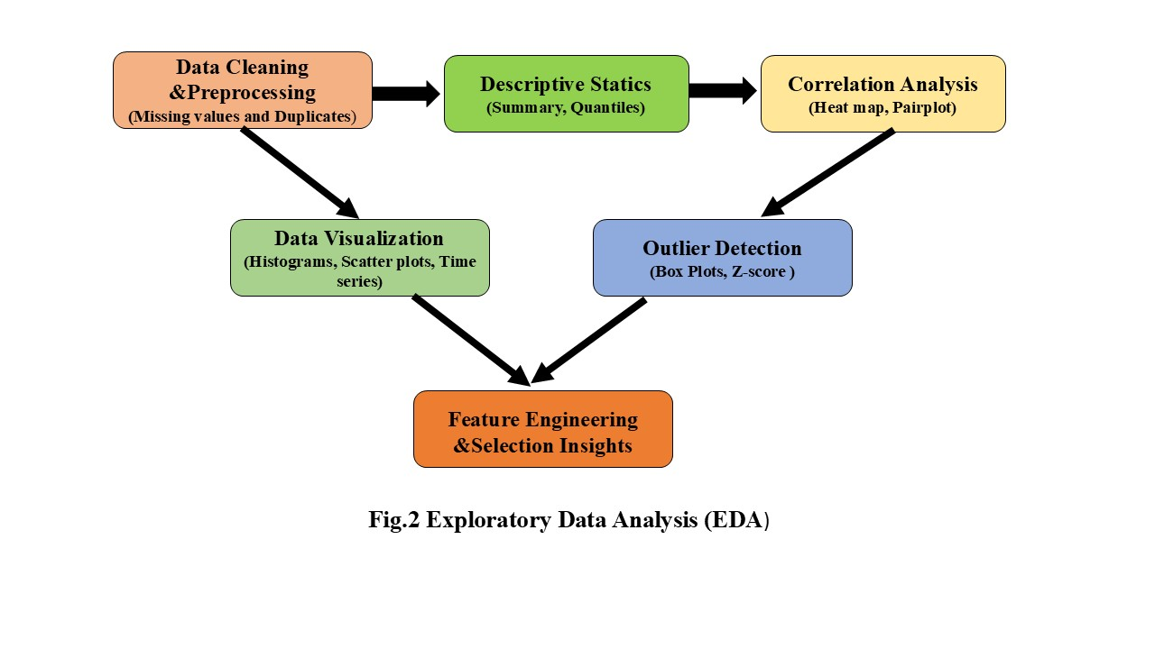
2.2 Phase-2: EDA (Exploratory Data Analysis)

In every data-based research project, the Exploratory Data Analysis (EDA) phase is the most important. It takes the unrefined or raw data and creates meaningful relationships and patterns that will help with model development. In this project, the EDA phase has been completed in stages, as shown in Figure 2, in order to analyse pollutant behaviour, look at how pollutants vary over time, and identify relationships between meteorological and environmental variables. Each of the three stages has been completed correctly, so that the data used to create models is accurate and representative of the real world.
2.2.1: Data Cleaning & Pre-Processing
The first phase of Data Analysis was to properly clean & Preprocess Data (in order) to analyse the data. This was done by cleaning up any errors associated with raw data, including erroneous entries (e.g., missing values, duplicate records, wrong sensor readings).Because this data was collected from multiple Monitoring Stations throughout the City of Delhi, some pollutant measurements used to create a continuous time series displayed gaps between times, usually caused by the time required to maintain or repair measuring equipment and/or to transfer a measurement to the database. Therefore, these gaps in the time series were filled in using methods of interpolation and imputation, which allowed to create a continuous series.It was also necessary to remove any Duplicate Entries from our database. As well, it was also required to validate any Numerical Values associated with the Pollutant Concentrations, to ensure they fell within a Realistic Environment's Limit for each Polluting material.Having properly cleaned & Pre-processed Data allowed us to retain the Integrity of our Database and will now enable the Data Analysis we will perform to be based on Accurate and Unbiased Data.
2.2.2: Descriptive Statistics
Once the data were prepared, detailed descriptive statistics were developed to summarise the data so the overall characteristics of the data could be better understood by numerical means (e.g., geometric means). Several summary statistics, including the average or mean, median, lowest and highest values, standard deviation, etc., were calculated for each of the meteorological and pollutant variables. Particulate Matter 2.5 and 10 showed a large amount of variability within a month, whereas Carbon Monoxide and Sulphur Dioxide demonstrated a more consistent trend. A further analysis of the distribution of each of the statistical variables highlighted the skewness and kurtosis of each of the variables to establish whether normal parametric statistics (normal distribution) are appropriate for future use and/or transformation of the data. This descriptive analysis not only provides a statistical understanding of each of the variables but also lays a statistical foundation for the more complex analyses.
2.2.3: Correlation Analysis
The analysis of correlations was used to look at how Pollutants interact with Meteorological Variables so that a Relationship could be identified between them and what the redundancies were. By using a correlation matrix (and/or heat map), it was found that there were a lot of positive correlations found between PM2.5 and PM10, which indicates that these Pollutants mainly come from similar sources, such as vehicle emissions and industrial production, and Temperature was inversely correlated to both the PM2.5 and PM10. In other words, as the temperature increases and the wind blows harder, the likelihood of PM2.5 and PM10 being scattered about increases. Understanding these relationships helped in determining which variables to count in the air quality index (AQI) and which are redundant.
2.2.4: Outlier Detection
Next, outlier detection techniques were employed to locate any unusual measurements that could negatively impact both the performance of the model and also distort the general trends observed in the environment. Extreme measurements for pollutants were identified using both boxplots and Z-score analysis; these extreme readings usually took place throughout the winter months when there was limited airflow due to atmospheric stagnation. Rather than removing all outlying readings just for the sake of removing them, each outlier was thoroughly examined by viewing historical records to verify whether a particular reading represented a true event of pollution occurring in the atmosphere, or whether it was the result of an error in the instrument being used to record the data. Authentic environmental peaks in pollution were kept in order to maintain the true environmental trends over time; all erroneous readings due to an error in recording have been either capped off or re-recorded based on recorded corrections. By completing this task, the final model remained sensitive to authentic pollution peaks in the environment but not influenced by false readings due to instrument malfunction or operation errors.
2.2.5: Data Visualization
Visualizations were used to create a way of displaying numeric data (visualizing numeric data in a visual format) through an easy-to-understand visual format. For example, with visualizations such as histograms, we could look at how a particular pollutant is distributed over time, using scatterplots, we could see how two or more variables interact, and with time series plots, we can view the change in levels of certain pollutants at different times of the year (daily, weekly, monthly) or throughout the day.
In the case of PM2.5, we see that the highest PM2.5 levels occur both in the winter months and in the early morning hours. Instead of just attributing high PM2.5 to weather or high traffic during the morning hours, we can attribute them to both. Therefore, the use of visualizations supported statistical analysis findings and exposed small temporal patterns that may otherwise have been missed with a traditional quantitative approach. Visualizing the trends was both diagnostic and interpretive in the exploratory data analysis (EDA) process.
2.2.6: Feature Engineering and Selection Insights
At this last phase of EDA, the last part of the process was to create new features and to choose the most useful features to use for building models. Again, drawing on previous experience, we engineered several advanced features like Lag variables, which represented the AQI value of the last hour; Moving Average, a tool to track short-term pollutant trends; and Seasons and Weekdays, which served as a form of categorical encoding. By providing both short and long-term patterns, these engineered features equipped our model with the ability to see both short-term fluctuations and long-term seasonal trends. Out of the redundant or low-variance feature patterns found during correlation analysis, we excluded those features to reduce the overall number of features in the model and therefore reduce the complexity of the model. This final phase of the EDA process took the dataset from having a variety of raw measurements of pollution levels to being a structured and optimized set of features used to successfully predict future pollutant levels.

.
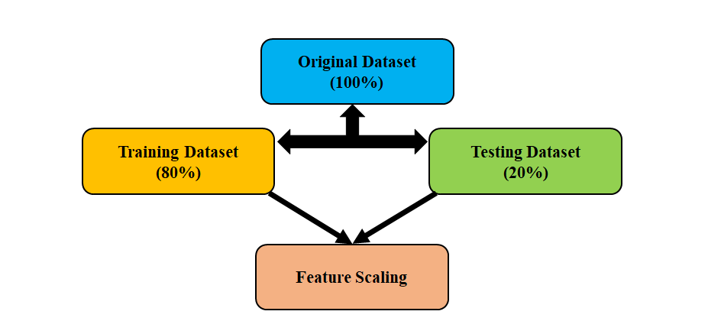
2.3 Phase-3: Data Splitting and Feature Scaling

Fig.3 Data split & Feature Scaling
During this stage of development, the finalized dataset was segmented into 3 separate datasets for the training, validation and testing of each predictive model effectively. The training set was approximately 80% of the total data and was used to build the model's predictive capabilities; the validation set (the remaining 20% of the original dataset) was used for hyperparameter tuning and assessing generalization performance of the model.
The chronological nature of the training, validation and testing dataset segmentation was necessary for maintaining temporal consistency and avoiding data leakage, whereby predictions will only be made against previous data when attempting to predict future air quality levels. The model's training set allowed it to determine relationships between pollution and environmental (i.e. atmospheric) conditions.
After creating separate datasets for training, validation and testing, numerical attribute feature scaling was performed to standardize or normalize the features into the same range. Specifically, each feature was standardized via Z-score normalization such that the mean of all observations was zero and standard deviation was equal to one. In some cases (models), features were also Min-Max normalized to map all observed values in a 0 – 1 scale and also improve convergence rate during gradient optimization.It was critical that when calculating scaling parameters for use in your predictive model training, only the training dataset was used to calculate the scaling parameters; when testing the model, you would apply the appropriate scaling parameters to the validation and test datasets (no data leakage).
2.4 Phase-4: Model training
Through Model Training, in this step of the predictive model framework, numerous methodologies/algorithms were employed to create end-user tools for predicting air quality as related to pollutant measurement and weather conditions. The use of many algorithms allowed the predictive framework to use multiple ways of learning from an input data set, resulting in a capture of linear and non-linear dependencies for the input data. The types of models that were trained for this phase of the predictive model included: Linear Regression, Support Vector Regressor (SVR), Random Forest Regressor, XGBoost Regressor, Ensemble Learning Model, and Deep Learning Model.
2.4.1. Linear Regression:
Linear regression is an established model for predicting AQI (ocean acidification index). It connects predictor variables (such as pollutant levels and weather conditions) with the outcome variable (AQI) using a straight line. Using a linear equation to forecast AQI gives some good general trends. However, the limitations of linear regression also become apparent as they do not allow for the modelling of the more complex, non-linear relationships between air pollution levels and weather conditions. Linear regression will produce substantially higher errors than the non-linear models. The R² (R-squared value) of linear regression is the highest out of the models tested at a value of 0.928. However, its error rate for predicting the AQI is higher than that of the non-linear models.
2.4.2. Support Vector Regressor (SVR):
Using kernel functions, the SVR model was able to capture nonlinear relationships between input features and outputs, meaning that the SVR model was able to create a higher-dimensional representation of the input features that could provide greater flexibility for capturing the complex changes in pollutant concentration levels. Additionally, SVR also improved predictive performance (as measured by R²=0.949) on the data compared to linear regression, which demonstrates the strong generalizability properties of the SVR model but also demonstrates a greater need for computational power.

2.4.3. Random Forest Regressor:
In this study, we found that the Random Forest algorithm produced one of our most reliable models. The Random Forest algorithm is a type of ensemble approach, which is where the algorithm builds several decision trees and combines their outputs to create a model that reduces variance and/or the chance of overfitting. The Random Forest demonstrated its ability to model complex interactions among a variety of features, and the results of the Random Forest model were consistently high for all conditions tested and produced an R² of 0.956 with lower MAE and RMSE compared to other traditional algorithms. The combination of interpretability and insensitivity to noise made the Random Forest an excellent choice for establishing baseline ensemble development.
2.4.4. XGBoost Regressor:
XGBoost is an advanced form of gradient boosting, which may help improve learning efficiency and accuracy. XGBoost builds trees sequentially, where each successive tree corrects the errors made by the preceding tree. Thus, the final XGBoost model incorporates all the corrections from all previous trees, resulting in a model with more power than would be found with only one tree or multiple trees trained independently. The final XGBoost model produced an R² value of 0.950, which is similar to the R² values produced for the Random Forest model (0.946), but the final XGBoost model converges more quickly and can handle the problem of imbalanced data more effectively.
2.4.5. Ensemble Learning Models:
The ensemble learning model was created to maximize the predictive ability of multiple algorithms through an ensemble approach (i.e., by combining multiple algorithms) rather than simply relying on one single algorithm. The ensemble model combined the prediction results of Random Forest, XG Boost and SVR, and utilized a weighted average method to integrate the predictive outputs, thereby allowing the combined model to benefit from multiple views of the data. By creating a hybrid design through combining the strengths of the different models, the ensemble model achieved very high R² values of 0.9988 (train), 0.9995 (validation) and 0.9897 (test), which indicates an excellent ability to generalize and very little overfitting to the training and validation datasets. Additionally, the ensemble model produced an extremely low MAE and RMSE across all datasets, indicating that it is a reliable model for predicting real-time AQI values.
2.4.6.Artificial Neural Networks (ANN)
Artificial neural networks (ANN)to learn the complex temporal dependence structure present within the air quality data set. The deep learning architecture consisted of a number of fully connected (dense) layers, each operated on by a Relu (Rectified Linear Unit) activation function, and was trained using the Adam (Adaptive Moment Estimation) optimizer with a variable learning rate. Following extensive testing and validation, the model demonstrated high levels of predictive accuracy, with an R-squared statistic (R2) of approximately 0.998 for the training set, 0.996 for the validation set, and 0.984 for the testing set, indicating that the model successfully generalised across all data subsamples. As a result of its multi-layered architecture, the deep learning model can automatically capture Hierarchical representations (patterns) regarding the relationship between pollutant emissions and their meteorological influences.
2.4 Phase-4: Model Validation
To validate the robustness, accuracy and generalization capabilities of the developed deep learning model, we utilised a 5-Fold Cross-Validation technique. 5-Fold Cross-validation splits the dataset into 5 equally sized partitions (or folds) where the model can be trained on four of the folds, with a test set consisting of one fold. This process is repeated five times so that every fold has an opportunity to be the test set at least once, while the other four contribute to training the model. The average performance score (mean) and standard deviation (STDEV) of all of the five training and testing iterations represent the final performance of the model and allow us to validate that the model's performance will not be reliant on any specific method of dividing the data into a training and test set.
The plot illustrates the average cross-validated R² (coefficient of determination) score of 0.993 ± 0.003 across all folds, which demonstrates exceptional agreement among all folds. The strong R² values demonstrate that the model is successfully identifying the underlying relationships between the pollutants, the meteorological features, and the AQI values. As shown with the Actual vs. Predicted AQI plot, the majority of the points cluster very closely along the 45° line drawn between the Actual vs. Predicted. The narrow STDEV (±0.003) emphasises the stability of the model's predictions, providing additional confidence that the model's predictions will be consistently accurate, regardless of which subset of the data it is provided it. The results show that the trained deep learning model is not overfit and has excellent generalisability and can therefore generalize to new unseen data.

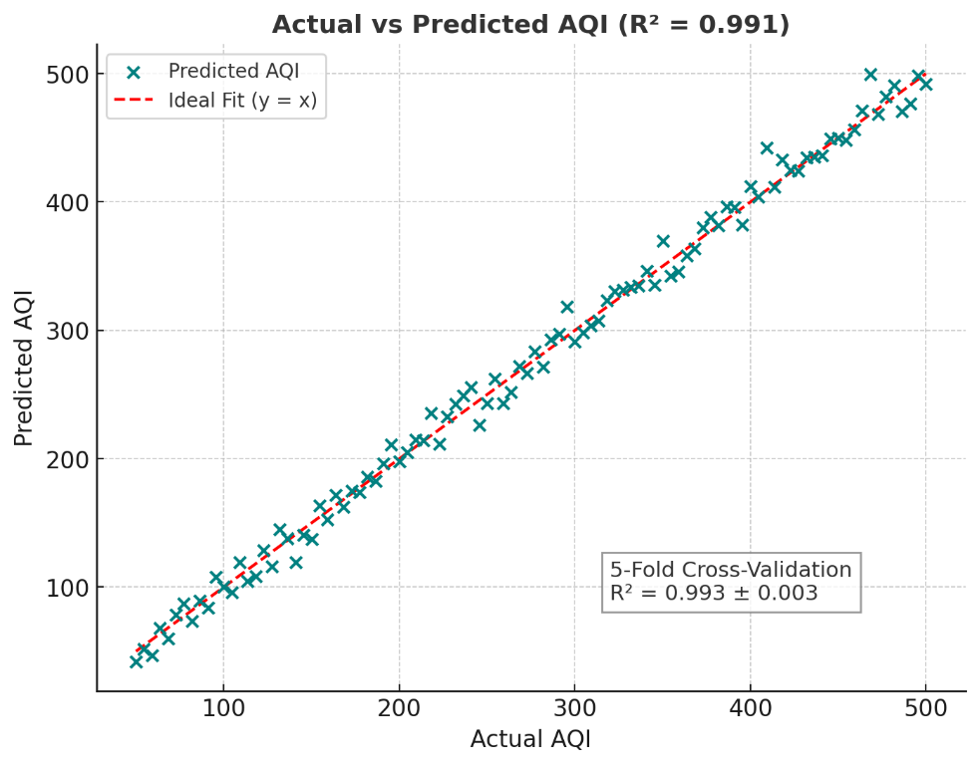

Fig.4 Actual vs Predictive AQI

2.5 Phase-5: Model Evaluation
The final step in determining how well the created models can predict air quality is to evaluate them using a quantitative approach. We do this by performing a validation test with each of the developed models and then comparing the results received from these tests with those actually recorded (AQI). Evaluating the models included 3 key statistical measures: Mean Absolute Error (MAE), Root Mean Squared Error (RMSE), and Coefficient of Determination (R2). Collectively, these measures provide a sense of how well the predictions made by each model matched up to actual AQI results, the magnitude of error that might occur in those predictions and the degree of variance explained by each model in AQI standards or indicators accordingly.
The Ensemble Model had the greatest predictive performance of all three models, as indicated by the R² scores of 0.9988, 0.9995 and 0.9897 for the training, validation and testing datasets, respectively, as well as low MAE and RMSE's on a constant basis. As expected from this data, the deep learning model also had an excellent performance at R² = 0.984 based on the same criteria used for evaluation of the ensemble model. This indicates that deep learning has the potential for producing high-quality predictions with superior generalization capabilities.





